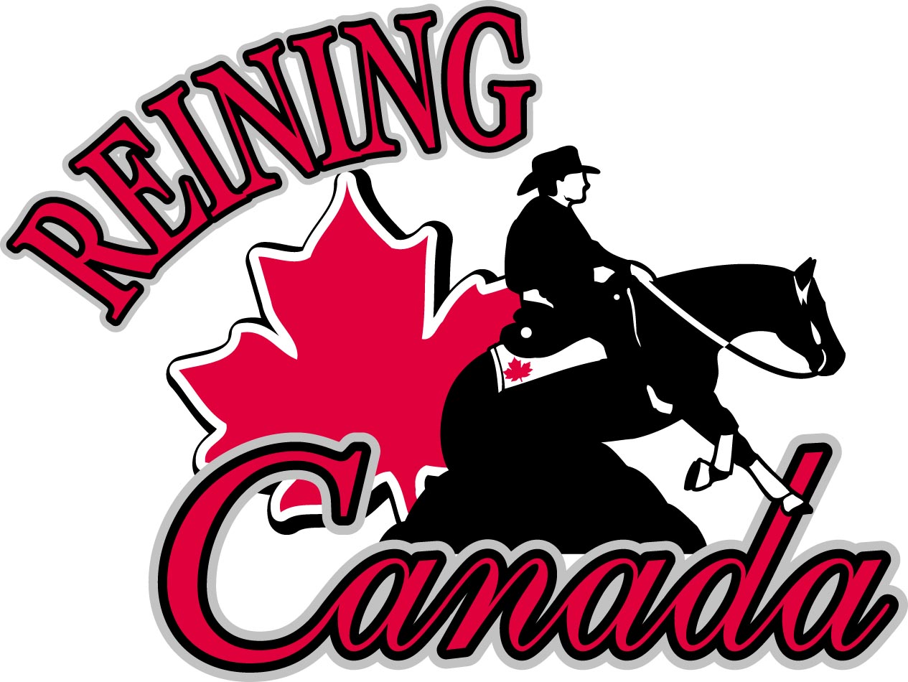

REINING CANADA CALL FOR NOMINATIONS October 20, 2020

RR2 Site 17 Comp 11
Sundre, Alberta T0M 1X0
Ph: (403) 638-6737 Fax: 1-(866) 258-4754
www.reiningcanada.com
admin@reiningcanada.com

The Reining Canada Board of Directors consists of the following ELECTED positions: Executive Committee including President-Elect, Vice-President, Secretary and Treasurer. In addition there are to be three (3) Elected Directors at Large. The Reining Canada Board of Directors must also name a minimum of two (2) and maximum of three (3) Appointed Directors at Large to hold office for a single year term.
The Board of Directors of Reining Canada, in accordance with the Reining Canada By-Laws, issues this Call for Nominations for the following Reining Canada Board positions commencing in 2021
Reining Canada President - Elect:
This is a three year position that automatically moves into the President role for 2022 and on to Past-President for 2023. The nominee for the President-Elect must have served one prior term on the Reining Canada Board of Directors and be a member in good standing of Reining Canada.
Reining Canada Vice President This is a two year position 2021 and 2022
Reining Canada Treasurer This is a two year position 2021 and 2022
Reining Canada Elected Director-at-Large: This is a two year position 2021and 2022.
RC NRHA Director Position (for 2021 and 2022): As the elected RC NRHA Director for Canada the individual will also automatically fulfill one (1) of the Director at Large positions on the NRHA Board. This position is the Western Canadian Affiliate Representative.
RC NRHA Director Position(for 2021and 2022: As the elected RC NRHA Director for Canada the individual will also automatically fulfill one (1) of the Elected Director at Large positions on the NRHA Board.
Please note: if an individual is elected as the RC NRHA Director they will also be required to fulfill the duties of a Reining Canada Director at Large to ensure cohesiveness among the RC Board of Directors. Should a candidate decide to run for both a RC and NRHA elected position and is successful, the elected position shall supersede the Director at Large position.
For example if a candidate runs for President-Elect and RC NRHA Director and wins on both Ballots, the candidate will serve the RC Board of Directors as the President-Elect and the RC NRHA Director and will vacate the Director at Large position.

Who is Eligible to be Nominated?
In order to qualify as a candidate:
a) for the RC positions a person must be a current member in good standing of Reining Canada.
b) for the RC NRHA Director positions a person must be a current member in good standing of both Reining Canada and the NRHA.
Definition: Member in Good Standing shall mean a person who believes and follows the objectives of the corporation, has no financial obligation to the Corporation and who the Board has approved for membership.
c) For the RC NRHA Director position the candidate must reside within Western Canada - including the Provinces of British Columbia, Alberta, Saskatchewan, Manitoba, NWT, Yukon
How to Nominate
In order to appear on the ballot and be considered for office a member can be nominated in one of the following methods:
a) Be nominated by the Board of Directors for an office. Not less than sixty (60) days prior to the end of the year the Board must submit to the Secretary a list of one (1) qualified candidate willing and able to hold office for every office of the Corporation.
b) A member may be nominated by the membership in writing to Reining Canada not less than sixty (60) days prior to the end of the year. Said request must clearly state the name of the Member who is qualified and willing to stand for election, a current curriculum vitae, and the office desired and be signed by the candidate and not less than TWO (2) members in Good Standing.
Nomination documents and proposed By Law Amendments must be received in the office of Reining Canada by no later than November 1, 2020. Faxes are acceptable to 1-(866) 258-4754. Email to admin@reiningcanada.com The Nominations & Governance Committee will place the names of all persons qualified on a ballot and cause said ballot to be sent to every member with the notification of the Annual General Meeting as per the Reining Canada Bylaws.
For further information on AGM notices, nominations and voting requirements please see the Reining Canada Bylaws posted on the Reining Canada website at Reining Canada and the NRHA Bylaws posted on the NRHA website at NRHA

REINING CANADA NOMINATIONS FORM 2021
(note: includes RC NRHA Director Position)
MUST BE RECEIVED IN REINING CANADA OFFICE BY NOV 1, 2020
**Please print clearly**

NOMINATION FOR:
NAME OF MEMBER _______________________________________NRHA Member # __________

OFFICE DESIRED: (President-Elect, Vice President, Treasurer, RC Elected Director at Large, RC NRHA Western Canadian Representative)

_______________________________________

AND/OR
RC NRHA DIRECTOR: __________________________________________________________________

SIGNATURE OF CANDIDATE: ____________________________________________________________

NOTE: IF you would like to run for BOTH be sure to state which RC Officer position AND the NRHA Director Position.

SIGNATURE OF SUPPORTING MEMBERS:

Print Name: ____________________________________________________ NRHA Member #_________

Signature: ____________________________________________________

Print Name: ____________________________________________________ NRHA Member #_________

Signature: ____________________________________________________

FOR OFFICE USE ONLY:

DATE NOMINATION RECEIVED: _____________________________________

RECEIVED BY Mail:_______________ Courier:___________________ Fax:__________________

